NORTH SOUTH UNIVERSITY



Project Report - 01

Name : Eshan Barua

ID : 1512058042

Section : 01

Semester : Summer-19

Subject : CSE 434 (Software Quality Assurance)

GitHub Link : <https://github.com/BaruaEshan/CSE434>

Submitted To : Shaikh Shawon Arefin Shimon (SAS3)

Submission Date : 30-07-2019

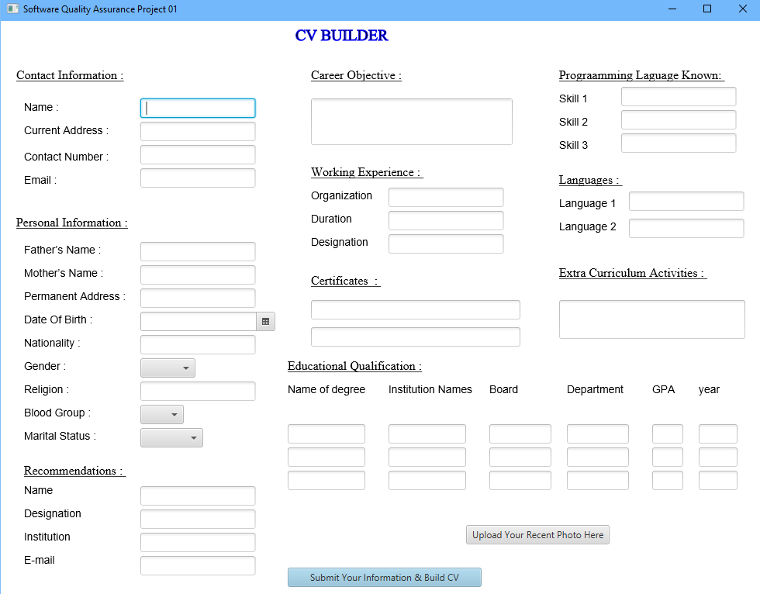

Figure – 1: JavaFx CV Builder Scene